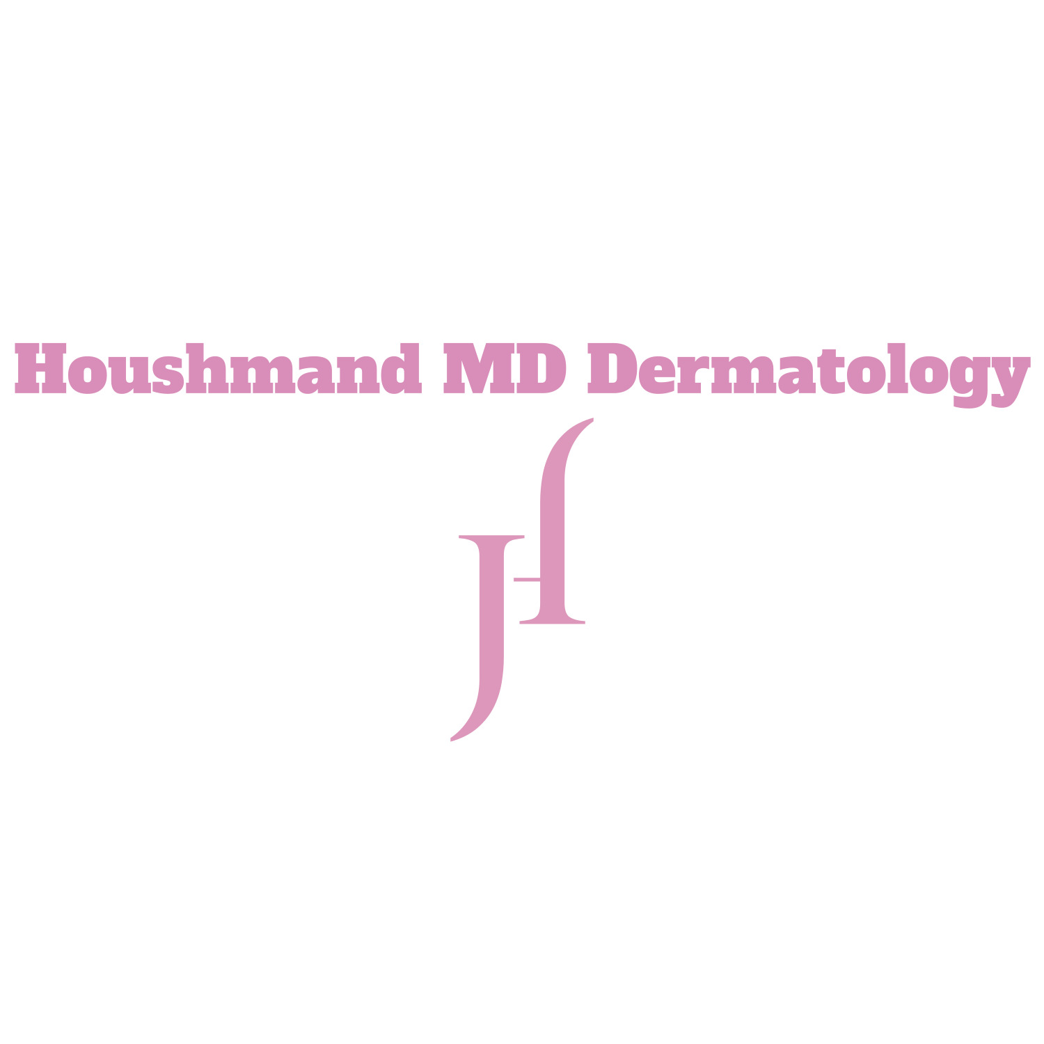

Name Date
Street Address
City State Zip Code
Email
Home Work Cell
Age D.O.B. SS# (for lab reports)
Driver License No./State
Employer Occupation
Marital Status: S/M/D/W Spouse’s Name Children
Pharmacy Name Phone

How did you hear about HoushmandMD Dermatology
Friend Magazine Physician
Website Social Media Speaking Engagement, location:
Brochure Direct Mail Other

REASON FOR VISIT/AREAS OF INTEREST:
 | Acne |  | Hair Loss |  | Nail diseases
 | Age Spots |  | Hand Rejuvenation |  | Rash
 | Anti-aging |  | Herpes Outbreaks / Cold Sores |  | Restylane/Perlane Injections
 | Botox/Dysport |  | Hives |  | Rosacea
 | Chemical Peels |  | Itching |  | Scars or scar revision (Keloids)
 | Collagen Injections |  | LASER Facial Resurfacing |  | Skin Health/Wellness Program
 | Complexion issue |  | LASER Hair Reduction |  | Skin Tags
 | Dry Skin |  | LASER for Pigmented Lesions / tattoos |  | Skin Cancer or Melanoma
 | Eczema |  | LASER for veins, red moles, or red scars |  | Sun Damage
 | Excess Sweating |  | LASER for Photorejuvenation/collagen thickening |  | Warts
 | Eyes or eyelids |  | Microdermabrasion |  | Wrinkles
 | Facial Lines |  | Micro-Needling |  | SKIN CARE PRODUCTS
 | Fungus/ fungal diseases |  | Moles or Growths |  | Other:

Health History Questionnaire Date: __ / /____
Name: Ht Wt_____ Ethnicity____________
Are you in good health? Are you under the care of a physician? No Yes If So Whom?
When was your last physical exam? Was everything O.K? Yes No
Please List Any Drug Allergies: ______________________________________
Please List All Medications You Are Currently Taking (Include Any Over the Counter Medications):
___________________________________________________________________________________________________________
I have taken Accutane in the past : □ YES □ NO
History of skin or other adverse reaction to: □ Latex rubber, □ Local anesthesia
PMH: Please List Any Current or Past Medical Illness with Dates: (Include All Hospitalizations, Surgeries, Injuries or Accidents)
_________________________________________________________________________________________
FH: Please list any illnesses/medical conditions in any family members: __________________________________________________________________
Social History: Smoking: □ Yes, __ packs per day; □ No. Alcohol: □ None, □ Occasional, □ Moderate, □ Excessive Recreational Drug Use: □ Yes □ No
REVIEW OF SYSTEMS: Please indicate any personal history of currently active problems below:
EYES: □ No, □ Yes: ___________________________________________________________________________
EAR/NOSE/MOUTH/THROAT: □ No, □ Yes: ___________________________________________________________________________
CARDIOVASCULAR: □ No, □ Yes: ___________________________________________________________________________
RESPIRATORY: □ No, □ Yes: ___________________________________________________________________________
GASTROINTESTINAL: □ No, □ Yes: ___________________________________________________________________________
GENITOURINARY: □ No, □ Yes: ___________________________________________________________________________
If Female: Are You Pregnant or Planning A Pregnancy? □ Yes □ No
MUSCULOSKELETAL: □ No, □ Yes: ___________________________________________________________________________
SKIN: □ No, □ Yes: ___________________________________________________________________________
NEUROLOGICAL/PSYCH: □ No, □ Yes ALLERGIC/IMMUNOLOGIC: □ No, □ Yes
OTHER: □ No, □ Yes: ___________________________________________________________________________
PATIENT SIGNATURE: _______________________________________________

Notice of Privacy Policy
Our Notice of Privacy Practices provides information about how we may use and disclose protected health information about you. The Notice contains a Patient Rights section describing your rights under the law. You have the right to review our Notice before signing this consent. White binders containing our Notice of Privacy are located in the waiting areas and at the check-in counter for your review. The terms of our Notice may change. If we change our Notice, you may obtain a revised copy by contacting our office.
You have the right to request that we restrict how protected health information about you is used or disclosed for treatment, payment or health care operations.
By signing this form, you consent to our use and disclosure of protected health information about health care operations. You have the right to revoke this consent, in writing, signed by you. However, such a revocation shall not affect any disclosures we have already made reliance on your prior consent. The Practice provides this form to comply with the Health Insurance Portability and Accountability Act of 1996 (HIPAA).

The patient understands that: (PLEASE CHECK EACH BOX)
- Protected health information may be disclosed or used for treatment, payment, or health care.
- The Practice has a Notice of Privacy Practices and that the patient has the opportunity to review the Notice.
- The Practice reserves the right to change the Notice of Privacy Polices.
- The patient has the right to restrict the uses of their own information, but the Practice does not have to agree to those restrictions.
- The patient may revoke this consent in writing at any time and all future disclosures will then cease.
- The Practice may condition treatment upon the execution of this consent.

This consent was signed by: _________________________________________________ Date: ____________
Printed Name – Patient or Representative

Relationship to Patient (if other than parent): ___________________________ Date: ___________

Due to the Health Insurance Portability and Accountability Act (HIPAA) of 1996, the following information must be filled out by each patient annually.

I authorize HoushmandMD Dermatology to release my medical records or insurance information as necessary to process my medical claims and coordinate or manage my health care.

In event a family member or caregiver attends my office visit and is in the exam room at the time of my evaluation and/or treatment, I give Dr. Houshmand, and staff members my permission to discuss freely my condition, treatment or diagnosis with that person. YES / NO

HOME PHONE: _____________________ May we leave a message? YES / NO

WORK PHONE: ______________________ May we leave a message? YES / NO

Will other co-workers such as administrative assistants, set up or cancel appointment on my behalf? YES/NO
If so, please list the name of the person(s) and their title below:
_________________________________________________________________________________________________

CELL PHONE: __________________________ May we leave a message? YES / NO

MAY WE CALL YOUR NAME OUT LOUD IN OUR LOBBY? YES / NO

WITH WHOM MAY WE DISCUSS FINANCIAL ISSUES, MEDICAL ISSUES, DIAGNOSES, & TREATMENT?

PATIENT NAME ________________________________ SIGNATURE __________________________________________ (Patient or Representative)
Witness______________________________

PATIENT PHOTOGRAPHIC AUTHORIZATION AND RELEASE
I authorize Dr. Houshmand and/or HoushmandMD Dermatology, and/or his representative(s), to take photographs, slides or video of me or parts of my body for the following procedure(s) and for medical purposes to be used for my care, medical presentations and/or articles.
In addition, I authorize the use of these images, without compensation to me, for the following specific purposes: (Please initial in the boxes marked Yes or No for each item)

YES | NO | MEDIUM
 |  | In the office photo album for prospective patients.
 |  | In office seminars for prospective patients.
 |  | On our website for prospective patients.
 |  | In print advertisement.
 |  | On television and social media
I understand that:
Such photographs, slides or videotapes may be published by Dr. Houshmand and/or Houshmand Dermatology in any print, visual, or electronic media including, but not limited to, all social media platforms such as: Facebook, Snapchat, Instagram,Tik Tok, medical journals and textbooks, scientific presentations and teaching courses, and Internet web sites, for the purpose of informing the medical profession or the general public about Dermatology methods. I understand that such uses may also include marketing on behalf of Dr. Houshmand, for which Dr. Houshmand may receive direct or indirect remuneration.

I will not be identified by name in any of the media described above; however, I also understand that in some circumstances the photographs, slides, or videotapes may display features that identify me.

I have the right to revoke this authorization in writing at any time and, if I decide to do so, I must present my written revocation to Dr. Houshmand at drhinfo@houshmandmdderm.com. A revocation shall not affect any release of information made prior to revocation in reliance upon this Authorization.
I may refuse to sign this authorization without such refusal affecting the medical treatment I receive from Dr. Houshmand and/or HoushmandMD Dermatology Associates.
The information disclosed under this Authorization, or some portion thereof, is protected by state law and/or the federal Health Insurance Portability and Accountability Act of 1996 (“HIPAA”). Any disclosure of information carries with it the potential for an unauthorized re-disclosure and the information may not be protected by applicable federal and/or state confidentiality rules.
I release and discharge Dr. Houshmand and/or HoushmandMD Dermatology Associates from all liability, including liability for negligence that in any way arises out of: any and all rights that I may have or may have had in the photographs, slides or videotapes of me that I have authorized to be used and disclosed in this Authorization; and any claim that I may have or may have had relating to such use and disclosure of those photographs, slides or videotapes of me, including any claim for payment in connection with any distribution or publication of them in any medium.
This Authorization is made as a voluntary contribution in the interest of public education and certifies that I have read this Authorization and Release carefully and fully understand its terms.
If I have questions about the use or disclosure of my photographs, slides, or videotapes, I can contact Dr. Houshmand at drhinfo@houshmandmdderm.com
Signature_____________________________________________Date_____________________
If Patient is a Minor: Patient is a minor (years of age), and we, the undersigned, are the parents or guardian of the patient and do hereby consent for the patient. Signature_____________________________________________Date_____________________

